**Electronically Steerable Catheter**

Zane Johnson, Tanner Karbonik, Erin McFadden, Michael Pass, Matt Situmeang  
University of Iowa, Biomedical Engineering Department  
BME:4910 Biomedical Engineering Senior Design

zane-johnson@uiowa.edu, 715-513-0253  
tanner-karbonik@uiowa.edu, 630-631-9927  
erin-mcfadden@uiowa.edu, 319-240-6463  
michael-pass@uiowa.edu, 641-330-9162  
matthew-situmeang@uiowa.edu, 319-217-9191

**Introduction:**

Heart disease is the leading cause of death in the United States and is responsible for nearly one in four deaths, accounting for over 600,000 each year [1]. Cardiac catheterization is commonly used for both diagnosis and treatment of heart disease. For these procedures, surgeons navigate a hollow tube (catheter) through a patient’s blood vessels as a minimally invasive treatment option. Although these surgeries have lower associated risk than fully-invasive procedures, complication risk grows appreciably as surgery time increases [2]. Our goal is to develop a novel method to improve the usability and actuation of steerable catheters to increase surgical accuracy and decrease procedure times.

Currently, there are two general types of steerable catheters: handheld, mechanical actuation, and automated, robotic actuation. Handheld devices may be cumbersome and awkward to work with, sometimes requiring two hands to operate, thus leading to increased procedural time. Robotic catheters cost millions of dollars, decreasing accessibility. This device aims to bridge the gap to give surgeons greater ease of use and accuracy at a lower cost all while improving patient outcomes by implementing electronic handheld control.

**Design Description:**

To be clinically relevant and effective, the catheter design is required to have electronic controls, one-handed usability, precise 180 degree actuation capabilities, sterility, low-cost, and a waterproof casing. These functional requirements can be captured in three critical design modules: handle design/user interface, power delivery, and electronic actuation.

The most critical module of the device is the mechanism used to pull tendons that actuate the tip of the catheter. For simplicity, we chose to use miniature stepper motors with 3D printed spools fixed to gears at the end of their respective motor shafts. The CAD drawing of a spool is shown in Figure 1. The tendons run down from the distal tip of the catheter to the spool. At each spool, wires were threaded through a hole in the spool wall and anchored with a knot. With this fixation method, wires could be wrapped around the spool without slipping.

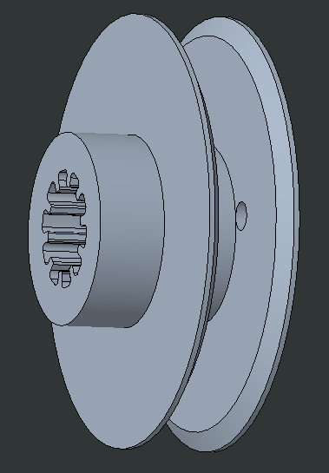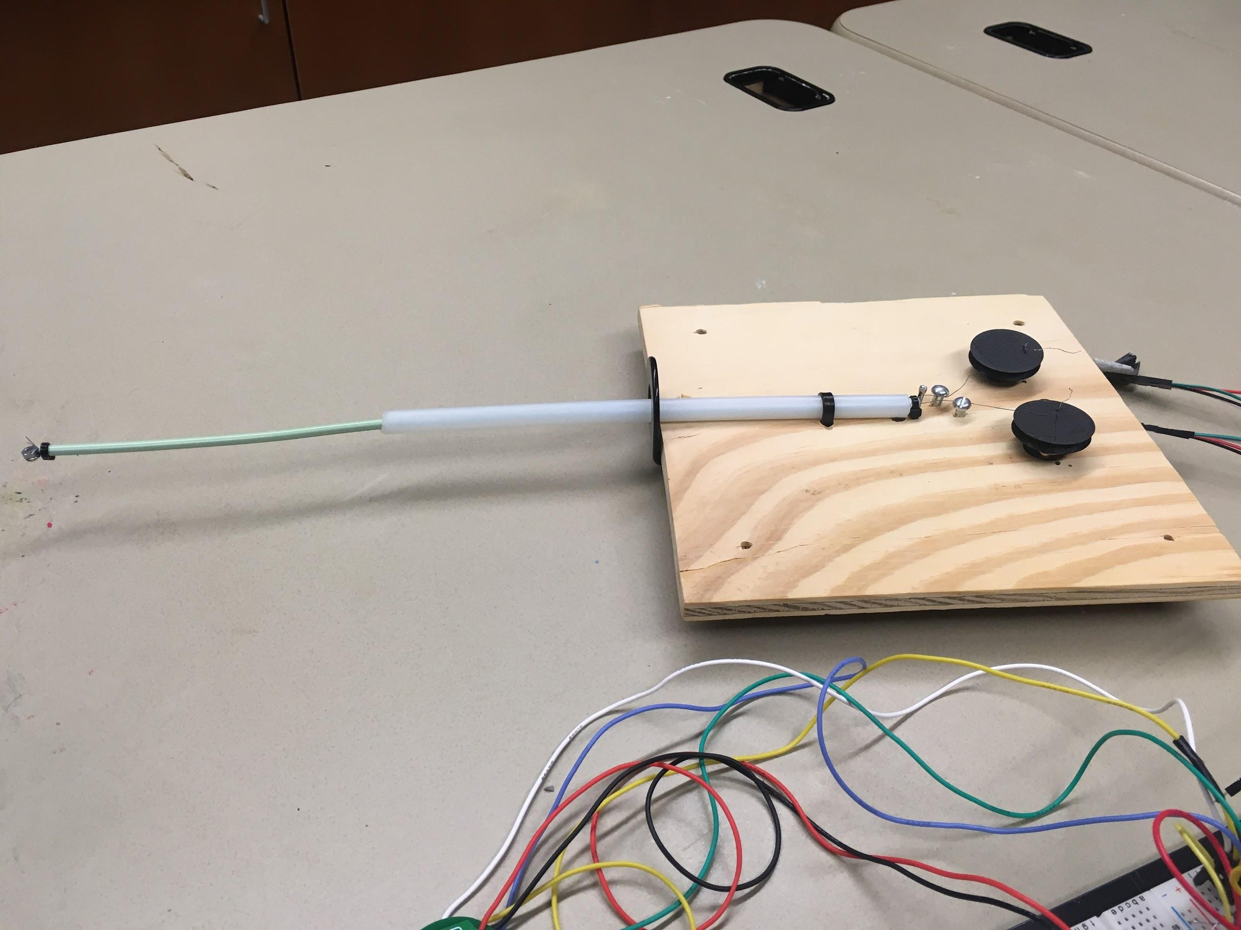  
Figure 1(left): CAD drawing of the spool 3D printed for wrapping the tendon. Figure 2 (right): Bi-directional steerable catheter prototype.

This prototype includes two motors that pull separate wires to direct the tip of the catheter in opposite directions in the same plane. The motors are controlled from an Arduino-based microcontroller that creates motion by turning the motors in opposite directions resulting in pulling one wire and loosening the other (Figure 2). The pull wires are enclosed in separate lumina in a multi-lumen extrusion. This extrusion is covered by a rigid outer sheath that prevents bending along the proximal length of the catheter. The current prototype is powered by a 12V wall power supply.

The Arduino receives user input from two momentary push buttons (Figure 3), one for each direction of actuation. When a button is pushed, a signal is sent to the motors to rotate in the corresponding directions to pull and loosen the proper wires.

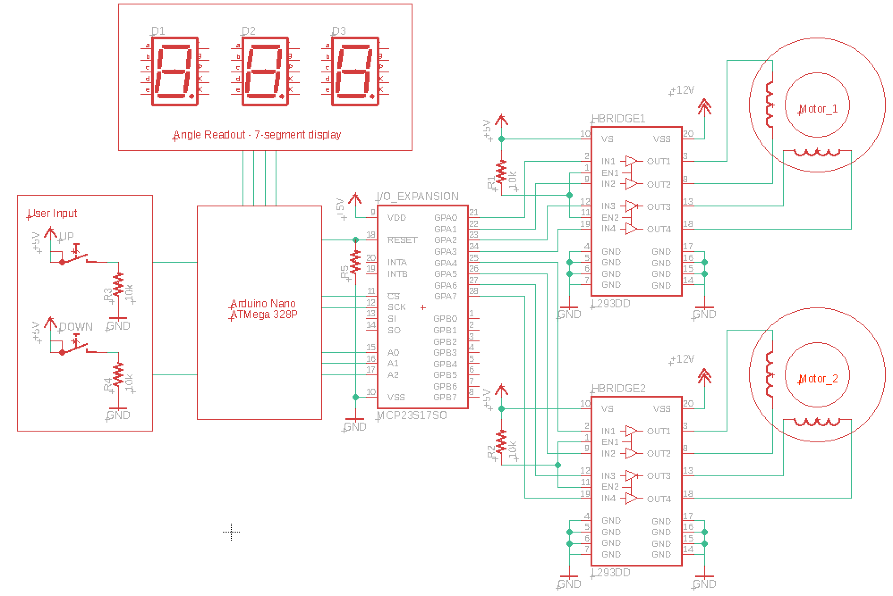

Figure 3: Top-level schematic of motor control.

**Evaluation of Design:**

Beam theory and statics concepts were used to mathematically test our design. By treating the distal tip as a beam, the angle of deformation (ϕ) was related back to the tension (T) in the wire (Figure 4) [3].

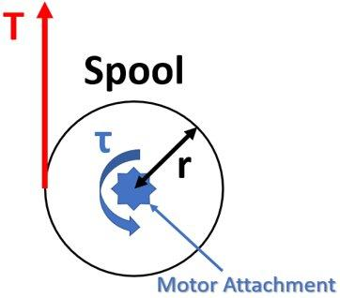 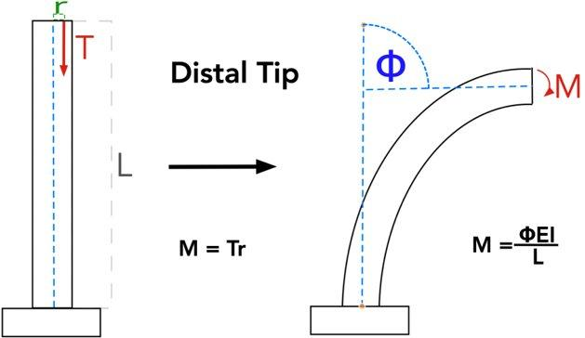  
  
Figure 4: Free body diagrams and equations of the spool and distal tip of the catheter. Note that the tensile force, T, generated by the torque applied by the motor is the same tensile force in the middle image.

A preliminary build was completed with a single spool and pull wire to test how much the tip would deflect with the current components. The radius of the spool was chosen to be 15mm to match common industry components. In this build, the motor and spool could deflect the tip about 30 degrees, which is short of our target deflection angle by 60 degrees. The tension force was measured with a force gauge to be 5.3N when generating a tip deflection angle of 30 degrees. With this measurement, the motor torque generated was calculated by multiplying the tension force (T) by the radius of the spool. Furthermore, the force gauge was used to measure how much tension was needed to deflect the tip to 90 degrees and was found to be 16.9N. A radius of 4.7mm was calculated and a new pair of spools was 3D printed for the final prototype.

With the new spool geometries, the total achieved bend angle was about 120 degrees in each direction. Because the 90 degree bend was surpassed, other options were considered to achieve a greater bend of 180 degrees. Originally, the power supply was set to 9V. This was not enough to produce the new desired bend. Therefore, the power supply was increased to 12V to give the motors more torque in order to reach a 180 degree bend, which was readily achieved.

Moving forward, additional analyses will be necessary to continue our design iterations. For example, the onset of plastic deformation in the pull wires around the spool will need to be evaluated. Based on the material properties of the wire, a minimum spool radius will be required to prevent permanent wire distortion. However, this will have to be balanced with the minimum force needed to bend the tip of the catheter to the desired 180 degrees. Similar equations can also be applied to the distal tip to calculate the minimum length needed for the distal lumen. With more of the distal lumen exposed from the sheath, less force is necessary to deflect the tip. This maximum length will be decided based on the procedure that the catheter will ultimately be designed for.

Finally, all of the components will need to fit into a catheter handle. This is another constraint in determining the desired spool size. With four motors and spools, it will be challenging to fit the components into a comfortable handle. Along with fitting the motors and spools inside, the circuitry and power delivery system will also need to be compressed for the handle to be able to accommodate all components. When the final wiring is completed with four motors, an angle readout display, control circuitry, and a PCB with minimal footprint will be placed in the handle. Power delivery will also be adapted from a wall adapter to source current from a small Li-Po battery and boost-converter module to allow for portable use.

**References:**

[1] Benjamin EJ, Muntner P, Alonso A, Bittencourt MS, Callaway CW, Carson AP, et al. Heart disease and stroke statistics—2019 update: a report from the American Heart Association. *Circulation*. 2019;139(10):e56–528.

[2] Lee, K. E., Seo, Y. J., Kim, G. B., An, H. S., Song, Y. H., Kwon, B. S., Noh, C. I. (2016). Complications of Cardiac Catheterization in Structural Heart Disease. *Korean circulation journal*, *46*(2), 246–255. doi:10.4070/kcj.2016.46.2.246

[3] Khoshnam, M., Azizian, M., & Patel, R. V. (n.d.). Modeling of a Steerable Catheter Based on Beam Theory. *2012 IEEE International Conference on Robotics and Automation*.